**Topics: Normal distribution, Functions of Random Variables**

1. The time required for servicing transmissions is normally distributed with *μ* = 45 minutes and *σ* = 8 minutes. The service manager plans to have work begin on the transmission of a customer’s car 10 minutes after the car is dropped off and the customer is told that the car will be ready within 1 hour from drop-off. What is the probability that the service manager cannot meet his commitment?
2. 0.3875
3. 0.2676
4. 0.5
5. 0.6987

**Answer-**

Let X= Time Required for transmission of customer’s car

If X is greater than 1 hour (60 min) indicates that service manager fails to meet his commitment.

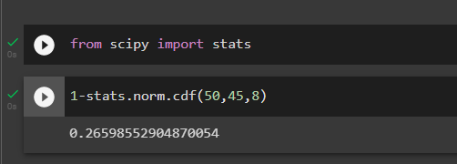

1. The current age (in years) of 400 clerical employees at an insurance claims processing center is normally distributed with mean *μ* = 38 and Standard deviation *σ* =6. For each statement below, please specify True/False. If false, briefly explain why.
2. More employees at the processing center are older than 44 than between 38 and 44.
3. A training program for employees under the age of 30 at the center would be expected to attract about 36 employees.

**Answer-**

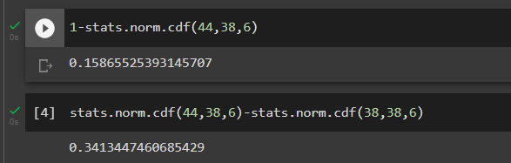

**False**- From above code it is clear that more employees at the processing center are between 38-44.

1. **True**

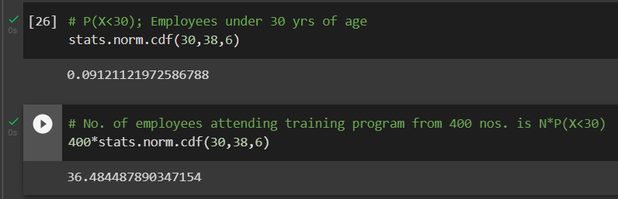

1. If *X1* ~ *N*(μ, σ2) and *X*2 ~ *N*(μ, σ2) are *iid* normal random variables, then what is the difference between 2 *X*1 and *X*1 + *X*2? Discuss both their distributions and parameters.

**Answer-**

Given that both X1 and X2 are independent and identically distributed.

Properties of normal random variable,

* The sum of normal random variables is given by

,

* The difference of normal random variable



* When Z= a*X, the product of X is given by



* When Z = a*X +b*Y, the linear combination of X and Y is given by



Finding 2X1,

2x1~N(2µ,22σ2) 🡪 2X1 ~ N (2µ,4 σ2)

Finding X1+X2, following addition property,

X1+X2~ N(µ+µσ2+σ2) ~ N(2µ,2σ2)

The difference between the two is given by,

2X1-(X1+X2) ~ N (2µ-2µ, 2σ2+4 σ2) ~ N (0.6 σ2)

The difference between the two says that the two given variables are identically and independently distributed.

1. Let X ~ N (100, 202). Find two values, *a* and *b*, symmetric about the mean, such that the probability of the random variable taking a value between them is 0.99.
2. 90.5, 105.9
3. 80.2, 119.8
4. 22, 78
5. 48.5, 151.5
6. 90.1, 109.9

**Answer-**

Given p(a<x<b) = 0.99, mean = 100 standard deviation = 20

Probability ranges from 0 to 1 and to get Probability of 0.99 we have to exclude 0.01 i.e., 0.005 on both the sides. Hence, we will have to find 0.5th and 99.5th percentile Z score values.

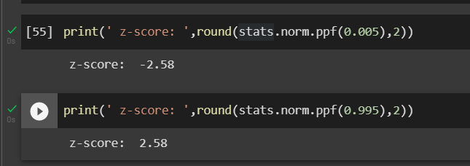

Z= X-µ/σ Rearranging the equation as X = Z*σ+µ

Substituting Both z scores in above equation,

a = -2.58*20+100 = 48.4

b = 2.58*20+100 = 151.6

Therefore, D is correct answer.

1. Consider a company that has two different divisions. The annual profits from the two divisions are independent and have distributions Profit1 ~ N (5, 32) and Profit2 ~ N (7, 42) respectively. Both the profits are in $ Million. Answer the following questions about the total profit of the company in Rupees. Assume that $1 = Rs. 45
2. Specify a Rupee range (centered on the mean) such that it contains 95% probability for the annual profit of the company.
3. Specify the 5th percentile of profit (in Rupees) for the company
4. Which of the two divisions has a larger probability of making a loss in a given year?

**Answer-**

Mean profit of the company = mean profit of 1st division + mean profit of 2nd division

=5+7 = 12

Mean profit in $ = 12*45 = $540millions.

Standard Deviation = sqrt. (9+16) = 5

Standard deviation in $ = 5*45 = $225 millions





To compute 5th Percentile, we use the formula X=μ + Z*σ, wherein from z table, 5 percentile = -1.645



